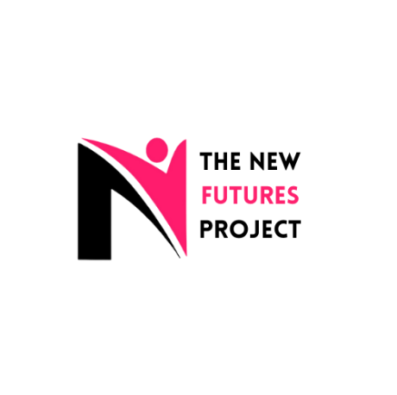
WOMEN (OVER 25) REFERRAL FORM
Our project offers a holistic service including counselling and one-to-one support. The client must be able to commit to weekly engagement and have practical support needs.

Details of the person being referred:
Name: | DOB: | Contact Number:
Address: | Ethnicity: | Religion:
Primary Language: | Interpreter required? | Email:

Support needs: Please tick (Must have at least one for referral to be accepted).
Accommodation: | Legal Issues: | Children:
Safety: | Health and Wellbeing: | Work and Learning:
Support Networks: | Money: | Empowerment and Self Esteem:

Additional needs:
Pregnant: | Substance Misuse: | Alcohol Support need:
Mental Health support need: | Physical health need: | Offending support need:

Referrer’s details: (If this is a self-referral, please go to next step)
Referrer Name: | Organisation details: | Contact number:
Email address: | Is this person aware of the referral? | Has this person been known to mental health services in the last 12 months?

Reason for Referral:

To work with you we need to keep some of your personal data, and information about the work we do with you, on our secure system.
We will only ask for information that is relevant to the work we do with you, or the work we do on your behalf.
Your data will not be given to anyone else without your consent unless the law, the Data Protection Act 2018 or our confidentiality policy requires or allows this. For example, if we believe there is a risk to yourself or someone else.
You can withdraw consent at any time.

Does the client give their consent for New Futures Project to keep their data?
☐ Yes ☐ No

The New Futures Project undertakes a risk assessment for any individual referred to our service. Please be aware you may be contacted regarding this.

